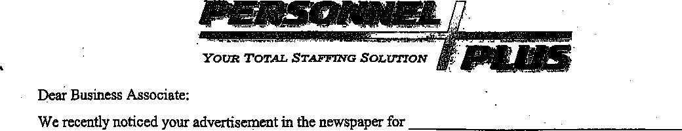
Personnel Plus is requesting that you give consideration to letting us to fill your opening. Why? You may ask. Because we have qualified candidates that are ready to work and we will save you the valuable time, expense, and frustration infilling this position.
Locally owned and operated, Personnel Plus, Inc. is one of the largest and most established staffing services in the Valley. We maintain a vast labor pool of qualified employees that have been pre-screened, drug screened, skills tested, interviewed, referenced checked and are ready to work on short notice. We can handle all of your staffing requirements whether short-term, temporary, long-term or permanent. Whatever your needs - general labor, clerical, administrative, call center, technical, or professional, we can help. We take care of everything; including payroll, withholding taxes, workers compensation, unemployment, and benefit administration. And that's not all the best feature about using our service, besides the convenience and time savings, is that you preselect only the most qualified candidate and then "test drive" them in their job for a probationary period before you ever commit to place them onto your own payroll. If the person doesn't work out, we arrange an immediate replacement.
What about the cost? Generally we can supply you a person at the same or lesser cost then your cost for doing the hiring yourself Consider all the costs of the hiring process - advertising, interviewing, screening, reference checking, background checking, drug testing, skill checking, payroll processing, tax withholding, unemployment, workers compensation and company benefits (vacations, holidays, health insurance, and retirement). When you compare all these costs, we will generally save you money. Also, statistics show that employers commit their valuable time to meticulously hire the right individual only to find a high likelihood that the individual doesn’t work out! The employer is forced to make a decision, suffer with a poor performer, or replace him/her and start the process all over again (hopefully without a discrimination complaint). The time and expense they invested in the hiring process is lost forever and can *t be recouped. The process is often repeated over and over until the right person is found. If this sounds familiar, then let the professionals at Personnel Plus staff your position. We will save you the valuable time, expense, and frustration involved, allowing you to focus on what you do best, running your business! Let our staffing professionals supply you with a qualified candidate of your choosing. We are waiting for your call and we GUARANTEE your satisfaction! Sincerely.
Marketing Representative Phone: 733-7300
111 Filer Avenue 735 Overland Avenue 5900 Overland Road 1116 Caldwell Blvd.
Twin Falls,.© 83301 Burley, ID 83318 Boise, ID 83709 Nampa, Idaho 83651
Tel (208) 733-7300 Tel (208) 678-4040 Tel (208) 378^8700 Tel (208) 466-6800
Fax (208) 733-7S62 Fax (208) 678-5655 Fax (208) 378-8750 Fax (208) 466-7148

